Interview of an RU student

Of Studies and Software Design



## Interviewer - Friðrik F. Söebech

## Course - T-216-GHOH (Greining og hönnun hugbúnaðar)

# 25/08/2023

# **Interview Intro:**

This interview was conducted for a Project done at Reykjavík University, the interviewee being one of many students there at the Uni. The subject matter discussed focuses on the tools they use during studies as well as software design.

Note: The writing is not exactly what was said in the interview, but it is a summation that gets the same point across as the answers given. In the future recordings would be a better interview method in my opinion.

# **Questions and Answers:**

Why did you choose to study computer science at Reykjavík University?

I’ve been fascinated by computers since childhood and therefore I wanted to pursue

further knowledge about them.

And why Reykjavík Uni specifically?

Because Reykjavík University is an esteemed institution with a good reputation that

focuses on teaching practical skills in this space.

When studying what support material do you usually use, like books, websites etc.?

I usually use a combination of YouTube, chat GPT, StackOverflow and the

PowerPoint presentations provided by the instructors.

What do you think supports you the most during your studies?

Having a good team that I can share my ideas with and learn from one another by

Talking to one another.

What do you think the purpose is for making software systems?

It differs depending on the goal being put forth but the main reason for me is to help

automate tasks that take a lot of time and are tedious as well as reducing human

error for dangerous tasks

Can you mention three software systems, websites or apps that you consider to be well designed?

Instagram

Hopp

Canvas

Can you now describe some examples of what makes these systems well designed?

For Instagram I find the Icons quite neat and descriptive with information being easy to find and understand.

I also like the how many options there are for sharing content with other people even if they are not on the same platform.

For Hopp I like how clear the information is on the

screen, you see everything you need pretty much on

on the screen at once.

I also like the multiple options for travel being in one

place.

For canvas I think that the courses are very well categorized having both a nice compact form factor and being color coded making it easy to understand.

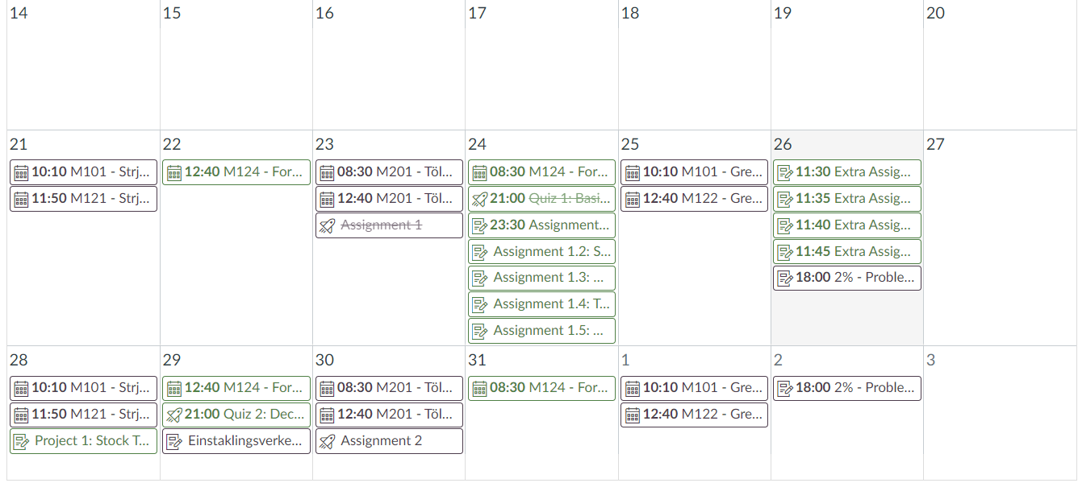

The calendar built into canvas is a very good feature of the application. It allows me to stay more organized and be notified of events that are important with informative color coated slots for each event.

Can you give me three examples of software systems, websites or apps that you believe to be poorly designed?

Piazza

The (old) Strætó app

Taxi hreyfill old

Can you now give me an example of why you think these have poor design, starting with Taxi hreyfill?

For starters it has a very outdated UI design that is quite hard to read. There is also no option here to select destination to determine accurate prices for your trip.

Selecting a date is also quite frustrating as the pickup time and the pickup date are both rolled into one.

Piazza as soon as you enter the site its just intimidating to look at, an overwhelming amount of information and a lot of buttons that you have no idea what do crammed into one screen. Looks hard to learn every function.



The main thing about the strætó app is that you cannot select location based on map services therefore you have to memorize the names of stops or be out of luck.

Note: This I find quite interesting as this feature does exist, yet the interviewee did not know of its existence this to me signals that this is not being communicated properly. I suspect its because the interviewee is English speaking and the language options are buried under the side menu(on the bottom right of this image).

How old are you?

I am 21.

Is there anything that you would like to add here at the end?

No theres nothing I would like to add.